|  | **VSea** | 9.08.2022 |
| --- | --- | --- |

| Document Type  **[SWI] Integration report tool** |
| --- |

| SW Version  **4.0.0** |
| --- |

| Author | | |
| --- | --- | --- |
| Mahmoud Elmohtady | SW Integrator | Email: mahmoud.elmohtady@valeo.com |

**Table of contents**

**Introduction** **3**

Release note 1

Purpose 2

Restrictions - important informations 2

**description** **3**

Overview 3

Tool Input 4

Reports Description 11

shortcuts

# Introduction

## Release note

This version is under user testing, working for VW polarion project

,100-KW , DAI and will be updated for other projects.

## Purpose

Main purpose of this tool is to automate Integration Report for a specific

release, or continuous report during release development.

## Restrictions - important information

* SWA baseline separated in polarion in one folder for each release
* Starting rolling build and local repository head to the merge which you want to generate report, in an otherway you have starting point and endpoint starting point refer to starting rolling build which release development starts with and end point is your local repo current head. and report will generate the difference between them

# Description

## Overview

Tool GUI consists of 3 main parts as in Fig-1

2.1.1 - Input data and this will be described in section (2.2)

2.1.2 - button to start generating reports

2.1.3 - progress bar and status label

progress bar will show the status of each report generation

and if there is something wrong will be reported with red color under it

Once tool generate report of any of selected from used

a message will be displayed that report generation completed

like [Fig-1]

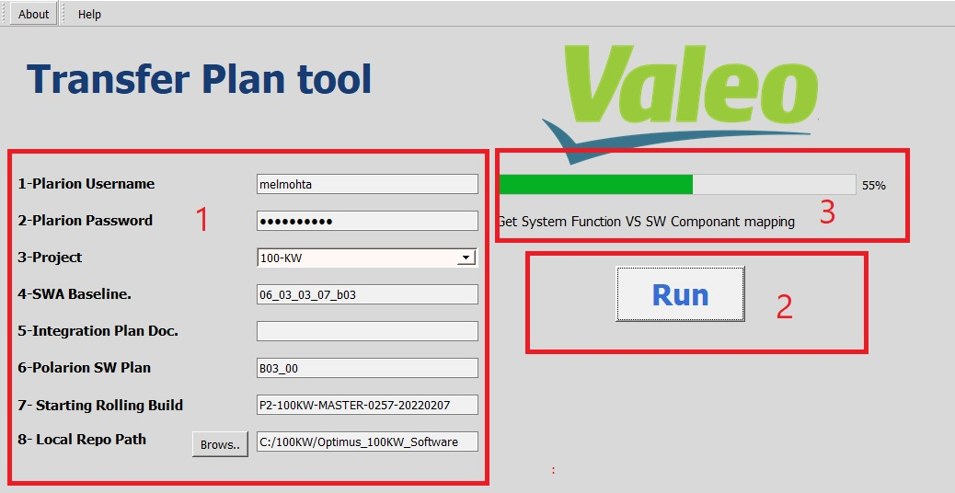

**[Figure -1]**

reportes generated in tool folder directory in folder called “Outputs”

## Tool Inputs

Inputs is like the following

2.2.1 - polarion Username

2.2.2 - polarion password

2.2.3 - polarion project

2.2.4 - polarion release baseline folder

ex: 24_11_1_19_p330

you will need to copy that from polarion like [fig-3]

2.2.5 - polarion integration plan document

[Currently not working in this version]

2.2.6 - polarion plan name (eg, “B03_00” in 100-KW project )

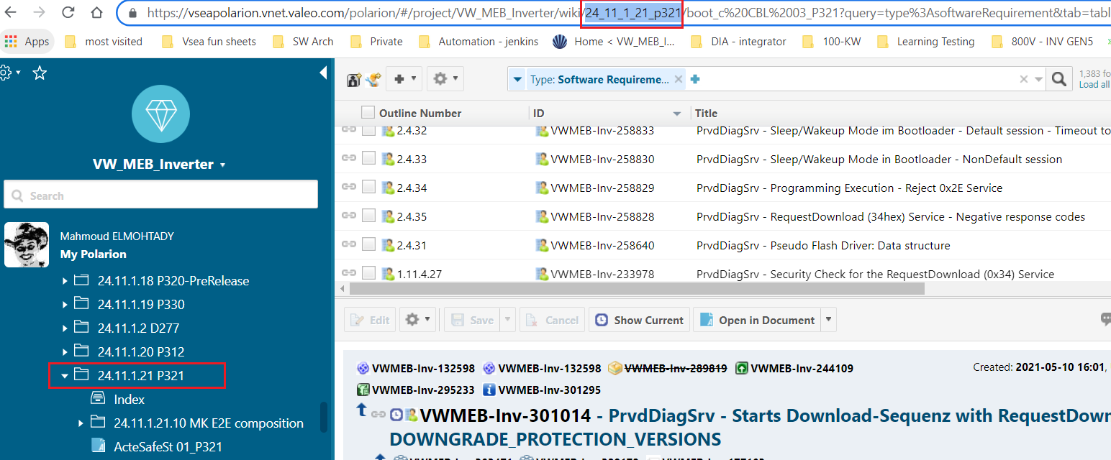

[figure - 3]

## Reports Description

report is generated in “OutPuts” folder under name “Integration_Final_Report”

and report consists of some columns [Fig - 4]

* “commit” : which has the Gerrit Commit ID
* “Author” Gerrit change Author
* “Change ID”
* “Gerrit Ticket” : which is polarion Ticket Id used in gerrit commit message
* “SWCs” the list of SWCs that have changes only “.c , .h” files
* “Functional affected SWCS” : list of SWCs which have a functional changes not comments of non functional changes
* “Affected System Function” : the affected system functions , and this is generated according to the SWC which referenced in SWC documents which is provided to tool in section [2.2.4]
* “Polarion Plan Verification”: which has 2 options [“✓” , “Not planned”], if the ticket used in commit message or its parent WIS has on polarion attributed planed in the given polarion plan will be considered as planned if not will appear in report as “Not planned” , see [Fig-5]

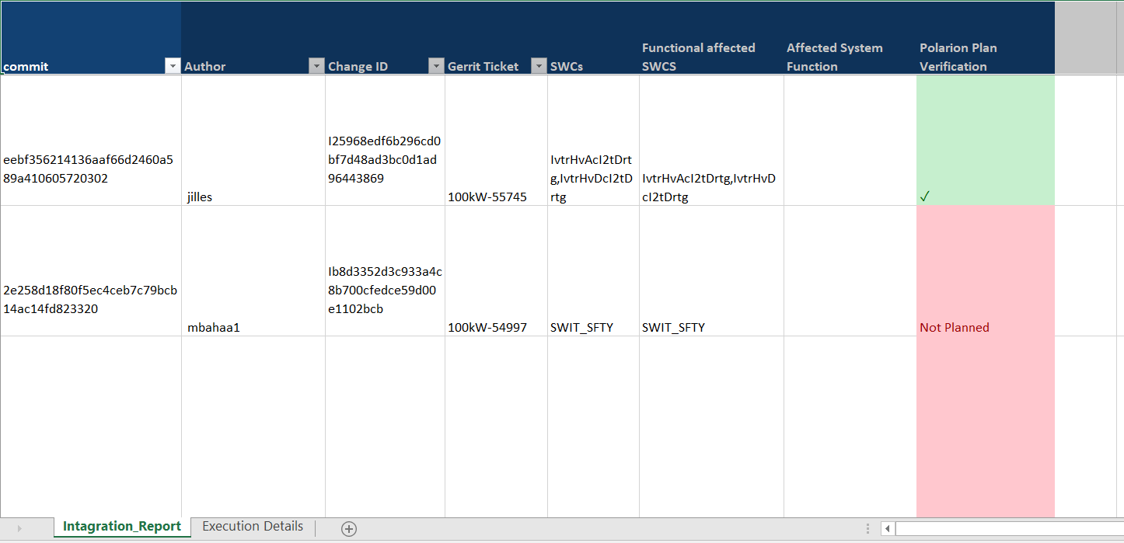

[Fig - 4]

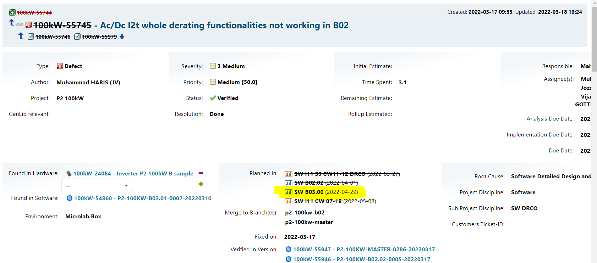

[Fig - 5]

## shortcuts

* SWA - software architecture
* SWREQ - software requirements
* SWC - software component
* DWI - diagnostic work items
* WIs - wort items
* SF - system finction